Name: Trần Anh Tuấn
Student ID: 24521943
Class: CS4323.Q12.CTTT

OS
LAB 2

CHECKLIST
1. Homework
 | 1 | 2 | 3 | 4
Explanation
Your code
Results and discussions

Mark:

2. Lab 2
1. List the contents of your /etc directory, including the ownership and permissions, and redirect the output to a file called report_<studentID>.txt within your home directory.
Answer:

Code: ls -l /etc > ~/Downloads/LAB02/report_24521943.txt

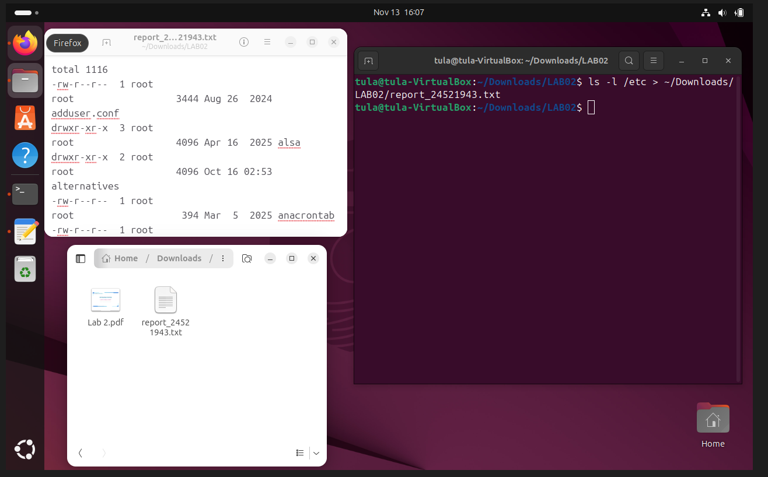

Explanation:
ls -l /etc
Lists all files in /etc with permissions, owners, group, size, and timestamps.
>
Redirects the output to a file (overwrites if it exists).
~/report_23560354.txt
Stores the report in your home directory
2. Sort the contents of the report_<studentID>.txt file from your current directory and append it to the end of a new file named report-sorted.txt.
Answer:

Code: sort report_24521943.txt >> report-sorted.txt

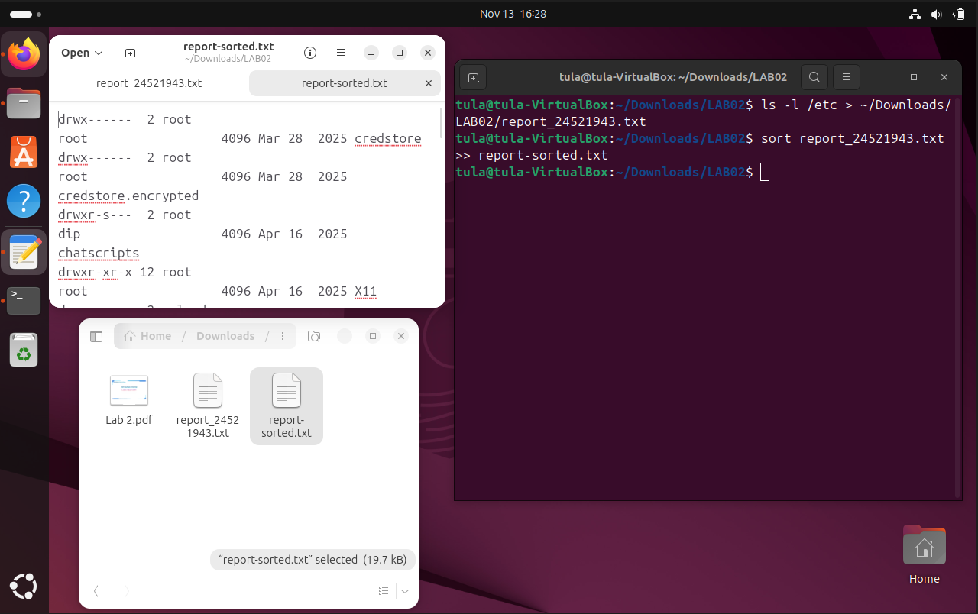

Explanation:
sort report_23560354.txt
Sorts the contents of the file alphabetically (line by line).
>> report-sorted.txt
Appends the sorted output to the end of report-sorted.txt.
If the file doesn’t exist, it will be created.

3. Count the number of words within the report_<studentID>.txt file and append the output to the end of a file field2.txt in your home directory. You will need to use both input and output redirection.
Answer:

Code: wc -w < report_24521943.txt >> ~/field2.txt
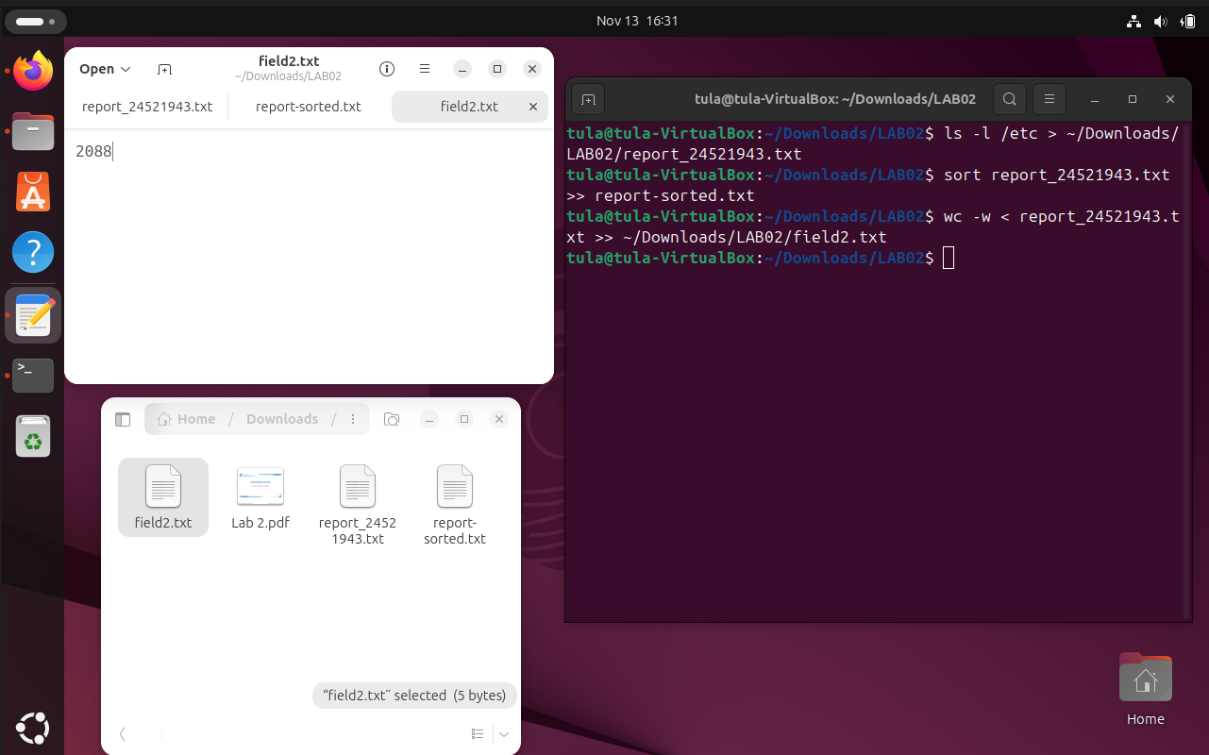

Explanation:
wc -w
Counts the number of words in the file.
< report_23560354.txt
This is input redirection — it sends the file content into the wc command.
>> ~/field2.txt
This is output redirection — it appends the result to the end of field2.txt in your home directory.
If field2.txt does not exist, it will be created.

4. Using the previously created report_<studentID>.txt file, count the number of characters of the last 9 lines.
Answer:

Code: tail -n 9 report_24521943.txt | wc -m

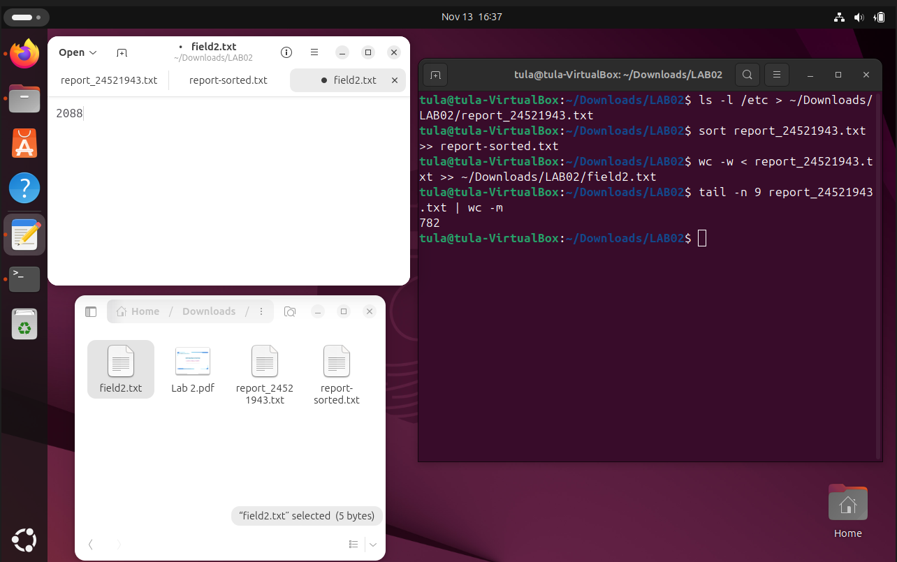

Explanation:
tail -n 9
Extracts the last 9 lines of the file.
wc -m
Counts the number of characters, including spaces and punctuation.
The output will be a single number — the total character count across those 9 lines.

